1.shell program to read a number and find its square.

Program:

echo "enter a number"

read n

square=`expr $n \* $n`

echo " $square"

output:

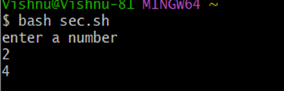

2.finding biggest among three.

Program:

echo "enter first number"

read num1

echo "enter second number"

read num2

echo "enter third number"

read num3

if [ $num1 -gt $num2 ] && [ $num1 -gt $num3 ]

then

echo $num1

elif [ $num2 -gt $num1 ] && [ $num2 -gt $num3 ]

then

echo $num2

else

echo $num3

fi

|  |
| --- |
|  |

Output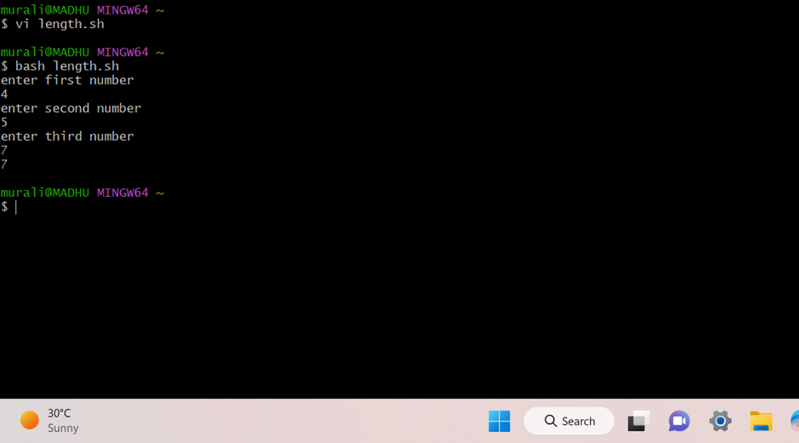

3.finding given year is leap year or not

Program:

echo "enter year"

read y

year=$y

y=$(( $y % 4))

if [ $y -eq 0 ]

then

echo "$year is leap year!"

else

echo "$year is not a leap year!"

fi

output:

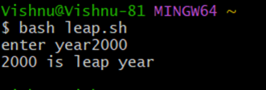

4.marklist preparation.

Program:

echo "enter the name of the student"

read name

echo "enter the marks in maths:"

read math

echo "enter the marks in science:"

read science

echo "enter the marks in english:"

read english

total=`expr $math + $science + $english`

if [ $total -ge 240 ];

then

grade="A+"

elif [ $total -ge 200 ] && [ $total -lt 240 ];

then

grade="A"

elif [ $total -ge 180 ] && [ $total -lt 200 ];

then

grade="B"

elif [ $total -ge 160 ] && [ $total -lt 180 ];

then

grade="C"

else

grade="fail"

fi

echoi "Name: $name"

echo "Marks in maths: $math"

echo "Marks in science: $science"

echo "Marks in english: $english"

echo "Total: $total"

echo "Grade: $grade"

output:

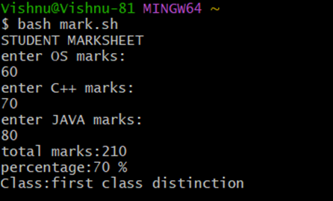

5. performing all arithmetic operations for two numbers.

Program:

echo "enter a"

read a

echo "enter b"

read b

val=`expr $a + $b`

echo "a + b : $val"

val=`expr $a - $b`

echo "a -b : $val"

val=`expr $a \* $b`

echo "a * b : $val"

val=`expr $b / $a`

echo "b / a : $val"

val=`expr $b % $a`

echo "b % a : $val"

if [ $a == $b ]

then

echo "a is equal to b"

fi

if [ $a != $b ]

then

echo "a is not eual to b"

fi

output:

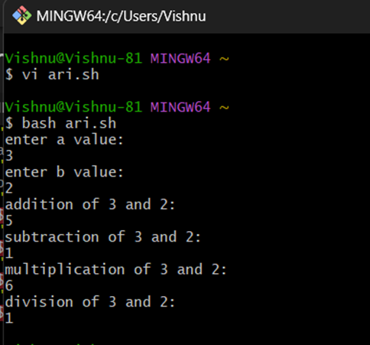

6.printing n natural numbers.

Program:

echo "enter n value"

read n

a = 1

for((i=1;i<=n;i++))

do

echo "$i"

done

output:

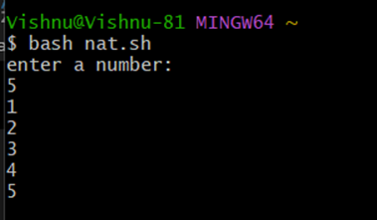

7.find area of different shapes.

Program:

echo "enter the side of the square"

read s

echo "enter the length and breadth of the rectangle"

read leng

read brea

echo "enter the radius of the circle"

read radius

echo "area of square is:`expr $s \* $s`"

echo "area of rectangle is:`expr $leng \* $brea`"

echo "area of the circle is: `expr 3.14 \* radius \* radius`"

output:

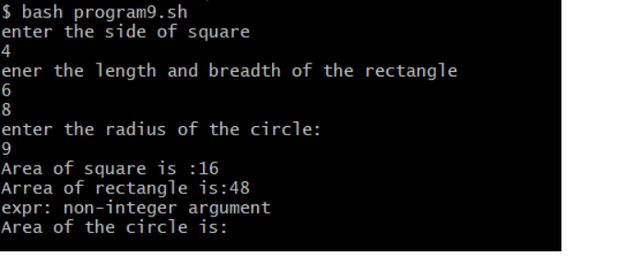

8.palindrome or not.

Program:

echo "enter n"

read n

function pal

{

number=$n

reverse=0

while [ $n -gt 0 ]

do

a=`expr $n % 10`

n=`expr $n / 10`

reverse=`expr $reverse \* 10 + $a`

done

echo $reverse

if [ $number -eq $reverse ]

then

echo "palindrome"

else

echo " not palindrome"

fi

}

r=`pal $n`

echo "$r"

output:

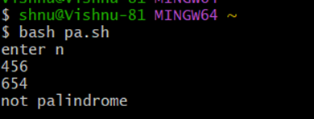

9.quadratic equation.

Program:

echo Enter the coefficient of x^2:

read a

echo Enter the coefficient of x:

read b

echo Enter the constant term:

read c

f=`echo "-($b)" |bc`

p=`expr 2 \* $a`

if [ $a -ne 0 ]

then

d=`echo \( \( $b \* $b \) - \( 4 \* $a \* $c \) \) | bc`

if [ $d -lt 0 ]

then

x=`echo "-($d)" | bc`

s=`echo "scale=2; sqrt ( $x )" | bc`

echo The first root is:

echo "($f + $s i) / $p"

echo The second root is:

echo "($f - $s i) / $p"

elif [ $d -eq 0 ]

then

res=`expr $f / $p`

echo The root is: $res

else

s=`echo "scale=2; sqrt( $d )" | bc`

res1=`echo "scale=2; ( $f + $s) / ( $p )"|bc`

res2=`echo "scale=2; ( $f - $s) / ( $p )"|bc`

echo The first root is: $res1

echo The second root is: $res2

fi

else

echo Coefficient of x^2 can not be 0.

Fi

output:

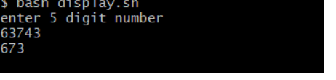

10.decimal to binary.

Program:

echo "Enter the num"

read n

val=0

power=1

while [ $n -ne 0 ]

do

r=`expr $n % 2`

val=`expr $r \* $power + $val`

power=`expr $power \* 10`

n=`expr $n \/ 2`

done

echo "Binary equivalent=$val"

output:

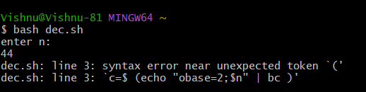

11.factorial using recursion.

Program:

read num

if((num == 0)); then

echo 1

else

factorial $num

fi

output:

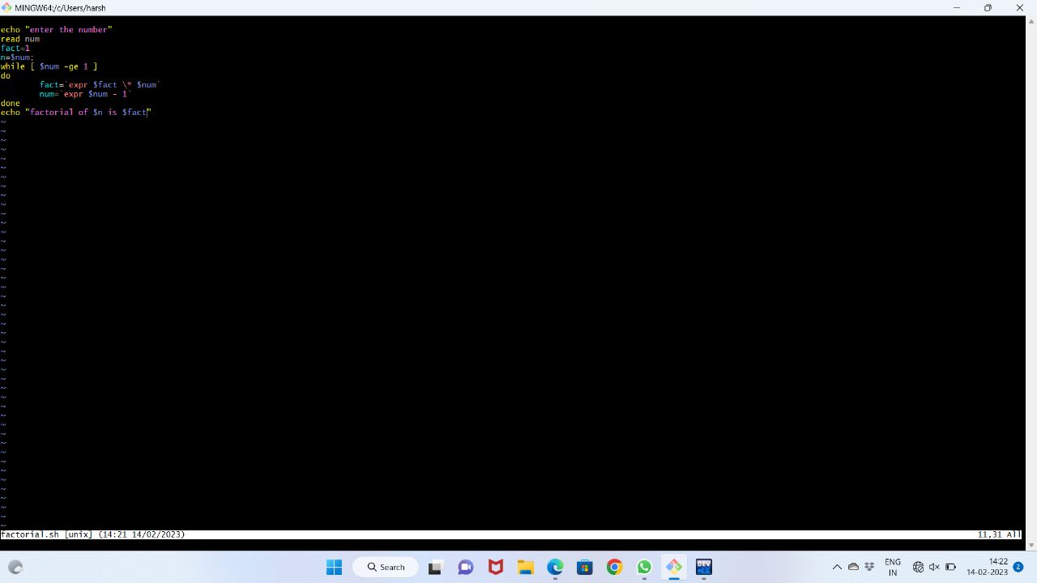

12.exchanging of two numbers.

Program:

first=5

second=10

temp=$first

first=$second

second=$temp

echo "after exchanging numbers are"

echo " first = $first, second = $second"

output:

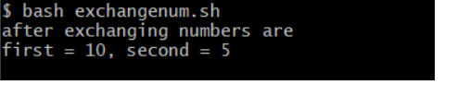

13.gcd of two numbers.

Program:

echo Enter two numbers with space in between

read a b

m = $a

if [ $b -lt $m ]

then

m = $b

fi

while [ $m -ne 0 ]

do

x = `expr $a % $m`

y = `expr $b % $m`

if [ $x -eq 0 -a $y -eq 0 ]

then

echo gcd of $a and $b is $m

break

fi

m = `expr $m - 1`

done

output:

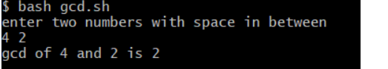

14. program to compare two strings.

Program:

echo "Enter the first string:" read strl

echo "Enter the second string

read str2

f [ $strl = Sstr2 ]

then

echo "'strings are equal"

else

echo "strings are not equal"

fi

output:

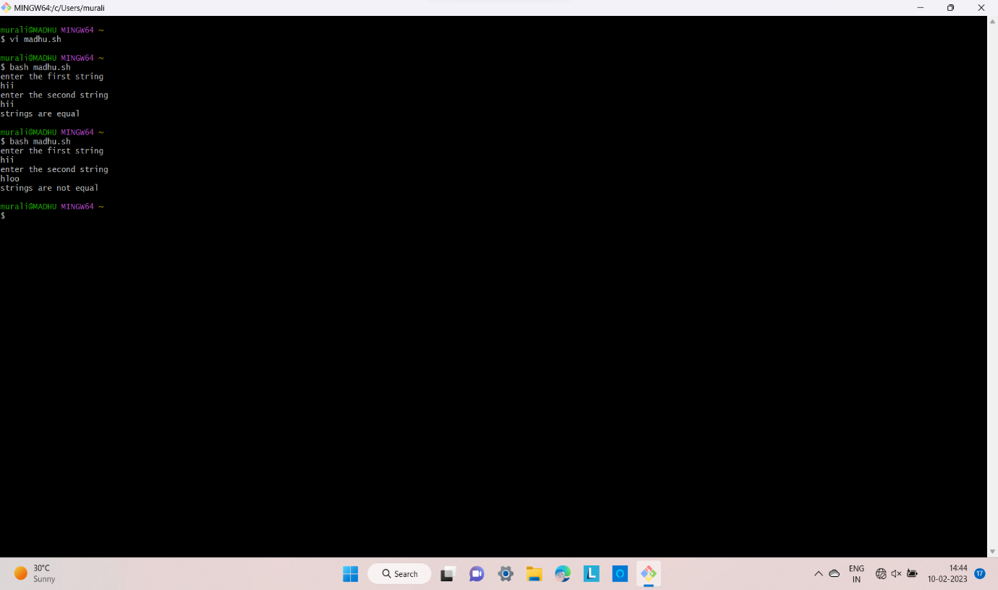

15.comcatenated string

Program:

echo "enter the first string"

read s1

echo "enter the second string"

read s2

s3=$s1$s2

len=`echo $s3 | wc -c`

len=`expr $len - 1`

echo "concatenated string is $s3"

echo "the length of the string is $len"

output:

